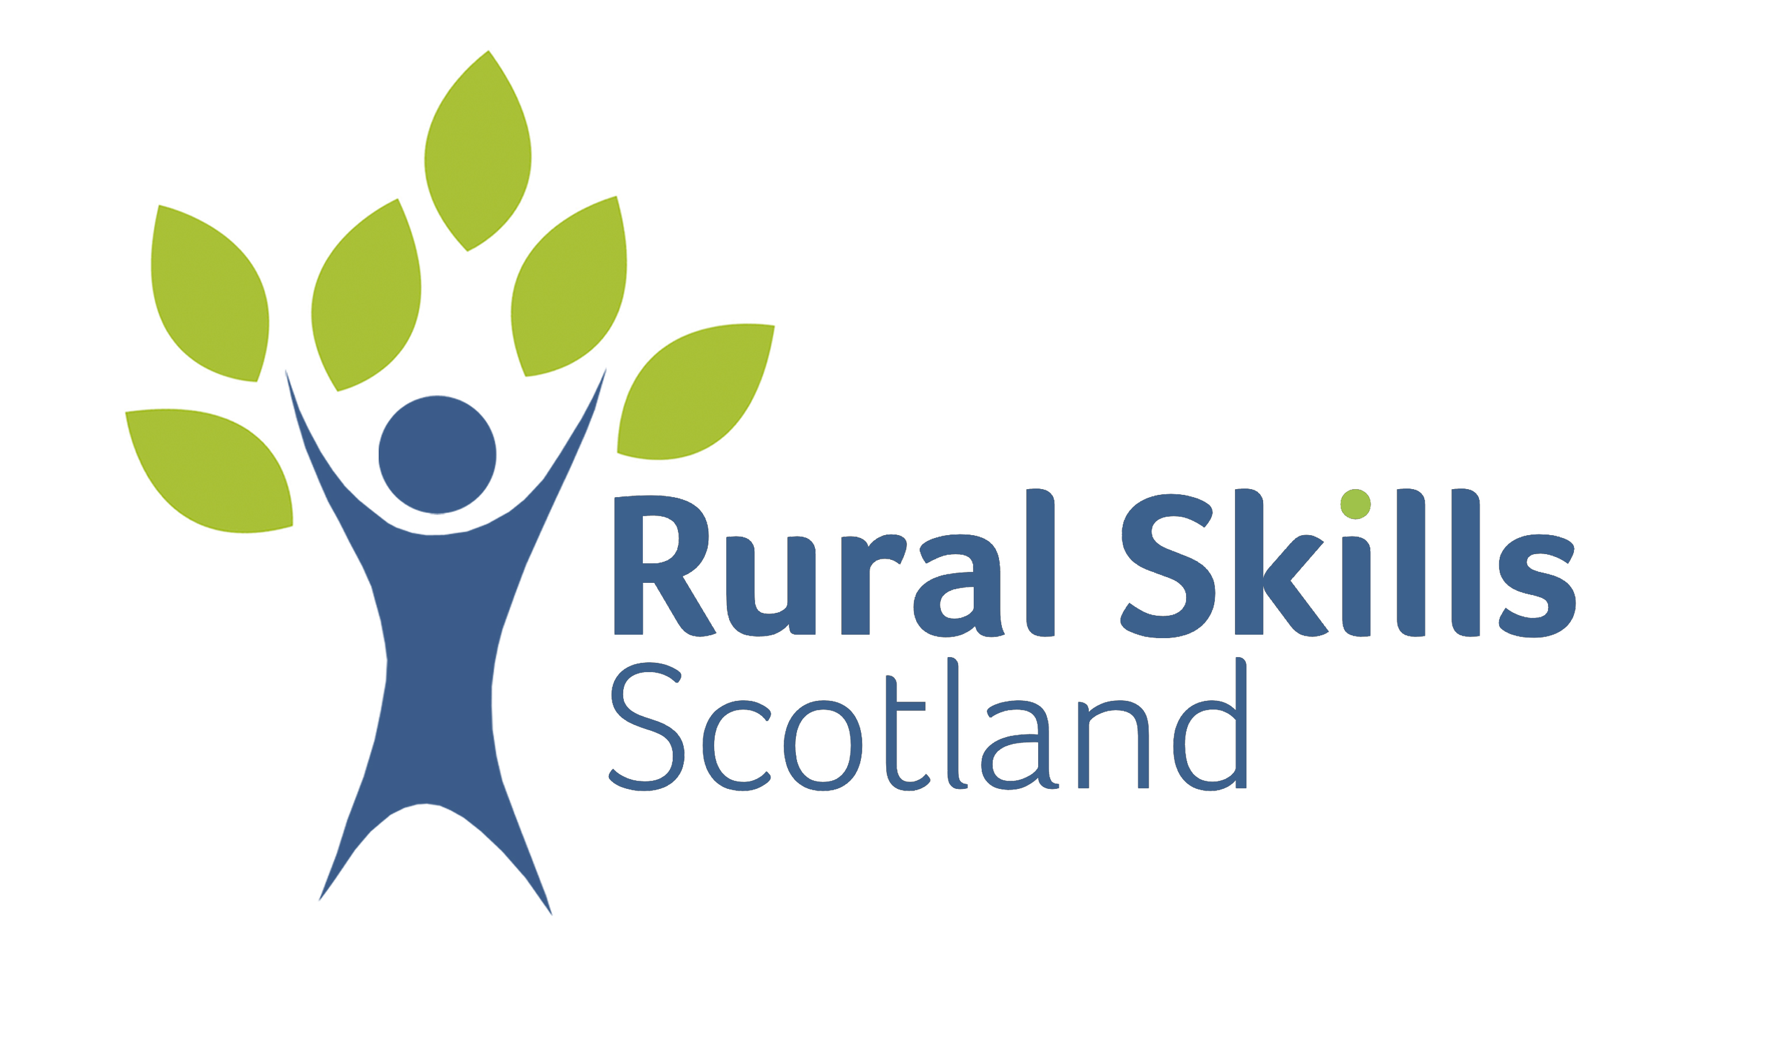

Operations Manager

Job Title | Operations Manager
Wage | £32,433
Location | Various locations throughout Fife
Shifts | 36 hours per week – Monday to Friday
Duration | Permanent
Number of vacancies | 1
Closing date | 6th August 2023
Company | Rural Skills Scotland Ltd.

Rural Skills Scotland Ltd. are a not-for-profit sharing company who are wholly dedicated to providing opportunities for people to gain skills and access to employment in the land-based sector. This is done through:

- Supporting the delivery of Apprenticeships and Vocational Qualifications across Scotland
- Direct delivery of employment through or sister contracting company
- The provision of pre-employment volunteering and employment opportunities through our Grounds for Growth Programme.

Based at Ravenscraig Park in Kirkcaldy, RSS are an ambitious organisation that are keen to grow and develop its business. As a result, we are seeking to engage an Operations Manager to work within our contracting business.

Through our contracting business, we currently provide forestry and estate maintenance activities across Fife and beyond working with public sector and private customers.

Responsibilities.

- Managing a programme of work for our contracting team including the preparation and submission of quotations for new work.

- Monitoring and reporting of work to the management team as required.

- Liaison with customers before during and after the completion of projects as appropriate.

- Provide line management for our contracting team.

- Have an overview of health and safety and risk assessment/management of the contracting team.

- Preparation of woodland management plans for our customers.

- Contribute to the overall development of the organisation.

The post is full time and permanent based on successful completion of 6 months probationary period. It is also based on a 36-hour working week, although some flexibility may be required depending on specific projects and workload.

The successful candidate will receive a competitive salary, access to the company pension scheme and 30 days leave per annum. As a training organisation, we are committed to providing opportunities for the development of all staff.

What experience do I need to have to apply?

 | Essential | Desirable
Skills and Qualifications | Educated to a degree level or equivalent experience in a land-based subject.  Ability to use Microsoft based computer packages.  Full clean driving licence  Current First Aid Certificate | Emergency First Aid +F Certificate  NPTC Qualifications in Forestry related subjects, e.g. chainsaw, brush cutter.
Specialist  Knowledge &  Skills | Experience of Risk Assessment and Management and the implementation of Health and Safety processes and procedures. | CSCS qualification  Preparation of woodland management plans and felling licenses
Interpersonal &  Communication  Skills | A passion for working in the land-based sector.  Excellent decision-making skills.  Ability to communicate with a wide range of individuals and groups at various levels of seniority.  Experience dealing with public, private and voluntary sector organisations.  Preparation of management reports
Relevant  Experience | Experience in a project management role  Budget management experience  Supervisory experience | Experience working in the land based sector.
Additional  Requirements |  | The ability to be flexible and adaptable as the role develops

